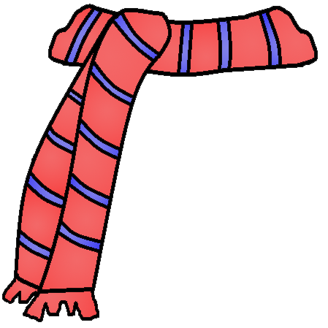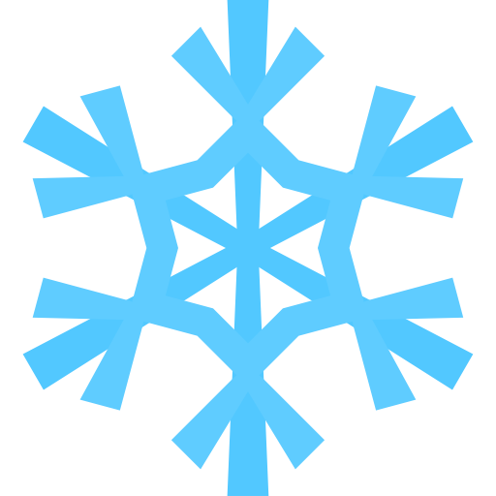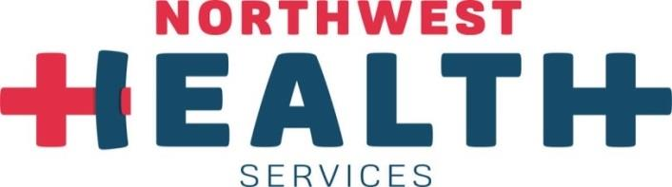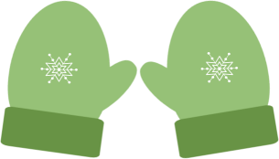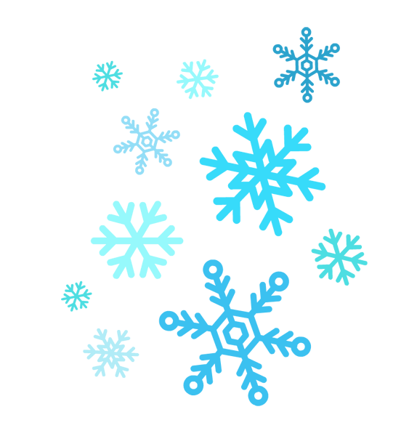0

**Diabetes and Pre-Diabetes 101**

**Thurs 1-9-20 @ 1pm**

**Tara Stevenson, RN, BSN, CDE**

**Merri Leach, MPH, RD, LD**

**Family Medicine Associates  
2303 Village Drive St. Joseph, MO 64506  
RN, CDE Phone: 816-901-1013  
RD Phone: 816-307-0600**

**Choose the class that’s right for you!  
Sessions are FREE for all patients with diabetes or pre diabetes. Family members are welcome. Call in advance to register.**

**January   
FREE Diabetes Learning Sessions**

**Preventing Complications  
 1-23-20 @ 1pm**

**Avoid the Winter Blues  
1-30-20 1pm**

**New Year’s Nutrition  
1-13-20 or 1-27-20 @ 1pm**

**Activity & Medication options  
1-16-20 @ 1 pm**