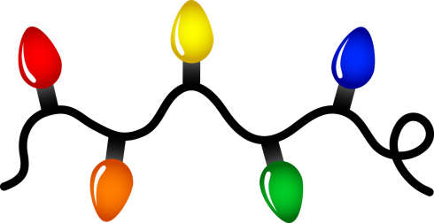

**Cope With Holiday Season Stress  
12-19-17 2019 1pm**

**Family Medicine Associates  
2303 Village Drive St. Joseph MO, 64506  
RN, CDE Phone: 816-901-1013  
RD Phone: 816-307-0600**

**Choose the session that’s right for you!  
Learning Sessions are FREE for all patients with diabetes and family members also welcome. Please call to register and reserve your spot!**

**Tara Stevenson, RN, BSN, CDE**

**Merri Leach, MPH, RD, LD**

**Healthy Holiday Eating  
12-09-2019 1pm (Monday)**

**Understanding Diabetes/PreDM  
 12-5-2019 1pm**

**December 2019  
FREE Diabetes Learning Sessions**